Full Name
Block #
Date
https://www.smore.com/xs1z8
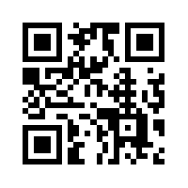Top portion is what yours will look like when you turn it into your teacher.
~~~~~~~~~~~~~~~~~~~~~~~~~~~~~~~~~~~~~~~~~~~~~~~~~~~~~~~~~~~~~~~~~~~~~~~~~~~~~~~~~~~~~~~~~~~
1.You will use www.qrstuff.com to create your QR code. Copy and paste your smore link on #2, then download.
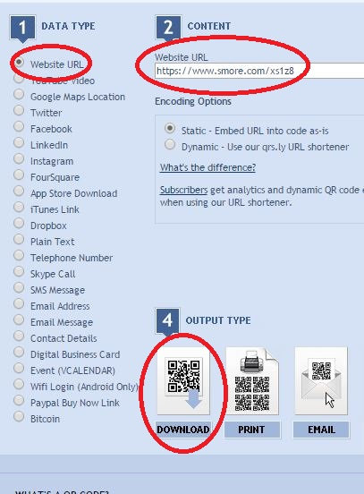
2. Copy and paste your code onto a Word Document. Then add name, block #, and date.
3. Print to one of the library printers and turn it in..

